**A**

**WEB TECHNOLOGY PROJECT REPORT**

**ON**

**Hotel Management System**

*In partial fulfilment of*

***B.E II year* (Computer Science & Eng.)**



**Submitted To: Submitted By:**

Mrs. Neelam Bohra Pranav Chouhan

Assistant Professor CSE, 2nd Year

d

had been impossible to finish my project if my supervisor Mr. Bipin Bhattarai and Mr. Bikash

Bhattarai were not there to support me and help me. Islington College was the reason I got to

work on the final year project (FYP). I am grateful to my client Kathmandu Prince Hotel for

accepting my proposal to develop the web application and co-operating with me when I needed

help and assistance.

In the end would like to show my gratitude to my peers and family who helped me during the

moments while I was completing my final ye

My final year project had a huge impact on my experience and also sharpened my skills. It would

had been impossible to finish my project if my supervisor Mr. Bipin Bhattarai and Mr. Bikash

Bhattarai were not there to support me and help me. Islington College was the reason I got to

work on the final year project (FYP). I am grateful to my client Kathmandu Prince Hotel for

accepting my proposal to develop the web application and co-operating with me when I needed

help and assistance.

In the end would like to show my gratitude to my peers and family who helped me during the

moments while I was completing my final ye

My final year project had a huge impact on my experience and also sharpened my skills. It would

had been impossible to finish my project if my supervisor Mr. Bipin Bhattarai and Mr. Bikash

Bhattarai were not there to support me and help me. Islington College was the reason I got to

work on the final year project (FYP). I am grateful to my client Kathmandu Prince Hotel for

accepting my proposal to develop the web application and co-operating with me when I needed

help and assistance.

In the end would like to show my gratitude to my peers and family who helped me during the

moments while I was completing my final ye

My final year project had a huge impact on my experience and also sharpened my skills. It would

had been impossible to finish my project if my supervisor Mr. Bipin Bhattarai and Mr. Bikash

Bhattarai were not there to support me and help me. Islington College was the reason I got to

work on the final year project (FYP). I am grateful to my client Kathmandu Prince Hotel for

accepting my proposal to develop the web application and co-operating with me when I needed

help and assistance.

In the end would like to show my gratitude to my peers and family who helped me during the

moments while I was completing my final ye

My final year project had a huge impact on my experience and also sharpened my skills. It would

had been impossible to finish my project if my supervisor Mr. Bipin Bhattarai and Mr. Bikash

Bhattarai were not there to support me and help me. Islington College was the reason I got to

work on the final year project (FYP). I am grateful to my client Kathmandu Prince Hotel for

accepting my proposal to develop the web application and co-operating with me when I needed

help and assistance.

In the end would like to show my gratitude to my peers and family who helped me during the

moments while I was completing my final ye

My final year project had a huge impact on my experience and also sharpened my skills. It would

had been impossible to finish my project if my supervisor Mr. Bipin Bhattarai and Mr. Bikash

Bhattarai were not there to support me and help me. Islington College was the reason I got to

work on the final year project (FYP). I am grateful to my client Kathmandu Prince Hotel for

accepting my proposal to develop the web application and co-operating with me when I needed

help and assistance.

In the end would like to show my gratitude to my peers and family who helped me during the

moments while I was completing my final ye

My final year project had a huge impact on my experience and also sharpened my skills. It would

had been impossible to finish my project if my supervisor Mr. Bipin Bhattarai and Mr. Bikash

Bhattarai were not there to support me and help me. Islington College was the reason I got to

work on the final year project (FYP). I am grateful to my client Kathmandu Prince Hotel for

accepting my proposal to develop the web application and co-operating with me when I needed

help and assistance.

In the end would like to show my gratitude to my peers and family who helped me during the

moments while I was completing my final ye

My final year project had a huge impact on my experience and also sharpened my skills. It would

had been impossible to finish my project if my supervisor Mr. Bipin Bhattarai and Mr. Bikash

Bhattarai were not there to support me and help me. Islington College was the reason I got to

work on the final year project (FYP). I am grateful to my client Kathmandu Prince Hotel for

accepting my proposal to develop the web application and co-operating with me when I needed

help and assistance.

In the end would like to show my gratitude to my peers and family who helped me during the

moments while I was completing my final ye

My final year project had a huge impact on my experience and also sharpened my skills. It would

had been impossible to finish my project if my supervisor Mr. Bipin Bhattarai and Mr. Bikash

Bhattarai were not there to support me and help me. Islington College was the reason I got to

work on the final year project (FYP). I am grateful to my client Kathmandu Prince Hotel for

accepting my proposal to develop the web application and co-operating with me when I needed

help and assistance.

In the end would like to show my gratitude to my peers and family who helped me during the

moments while I was completing my final ye

My final year project had a huge impact on my experience and also sharpened my skills. It would

had been impossible to finish my project if my supervisor Mr. Bipin Bhattarai and Mr. Bikash

Bhattarai were not there to support me and help me. Islington College was the reason I got to

work on the final year project (FYP). I am grateful to my client Kathmandu Prince Hotel for

accepting my proposal to develop the web application and co-operating with me when I needed

help and assistance.

In the end would like to show my gratitude to my peers and family who helped me during the

moments while I was completing my final ye

My final year project had a huge impact on my experience and also sharpened my skills. It would

had been impossible to finish my project if my supervisor Mr. Bipin Bhattarai and Mr. Bikash

Bhattarai were not there to support me and help me. Islington College was the reason I got to

work on the final year project (FYP). I am grateful to my client Kathmandu Prince Hotel for

accepting my proposal to develop the web application and co-operating with me when I needed

help and assistance.

In the end would like to show my gratitude to my peers and family who helped me during the

moments while I was completing my final ye

My final year project had a huge impact on my experience and also sharpened my skills. It would

had been impossible to finish my project if my supervisor Mr. Bipin Bhattarai and Mr. Bikash

Bhattarai were not there to support me and help me. Islington College was the reason I got to

work on the final year project (FYP). I am grateful to my client Kathmandu Prince Hotel for

accepting my proposal to develop the web application and co-operating with me when I needed

help and assistance.

In the end would like to show my gratitude to my peers and family who helped me during the

moments while I was completing my final ye

My final year project had a huge impact on my experience and also sharpened my skills. It would

had been impossible to finish my project if my supervisor Mr. Bipin Bhattarai and Mr. Bikash

Bhattarai were not there to support me and help me. Islington College was the reason I got to

work on the final year project (FYP). I am grateful to my client Kathmandu Prince Hotel for

accepting my proposal to develop the web application and co-operating with me when I needed

help and assistance.

In the end would like to show my gratitude to my peers and family who helped me during the

moments while I was completing my final ye

**ACKNOWLEDGEMENT**

**_____________________________________**

I would like to acknowledge all those without whom this project would not have been successful. Firstly, I would wish to thank our Assistant professor Mrs. Neelam Bohra who guided me throughout the project and gave her immense support. He made us understand how to successfully complete this project and without him, the project would not have been complete.

This project has been a source to learn and bring our theoretical knowledge to the real-life world. So, I would really acknowledge his help and guidance for this project.

I would also like to thank my parents who have always been there whenever needed.

Once again, thanks to everyone for making this project successful.

Pranav Chouhan

# 1. Table of Contents

|  |  |
| --- | --- |
| **ACKNOWLEDGMENT** | **2** |
| **1. TABLE OF CONTENTS** | **3** |
| **2. INTRODUCTION** | **4** |
| **3. TECHNOLOGY USED IN PROJECT** | **5** |
| **4. TECHNICAL DETAILS OF PROJECT/STUDY** | **6** |
| **4.1 Architectural Overview** | **6** |
| **4.2 Functions/Modules Details** | **6** |
| **4.3 Flow Chart** | **7** |
| **4.4 Project Code** | **7** |
| **4.5 Project Screenshot** | **8** |
| **5. APPLICATIONS** | **12** |
| **6. CONCLUSION** | **14** |
| **7. REFERENCE** | **14** |
|  |  |

# 2. Introduction

This is a software system that incorporates various factors needed for smooth working and management of a hospital. This hospital management system allows administrator to store and manage various resources according to patients and doctor's requirements. The project is developed to eliminate human efforts in managing hospital records and data manually.

The project includes beds/normal accommodation/ICU accommodation as well as patient data. In case a new patient arrives, the administrator can check for bed availability in various hospital departments and allocate it accordingly as per the patient need. The system also stores the patient data in a well-defined manner. The patient details include his name, number, address and various health parameters and resources being used by them. It also maintains all doctor’s information working in the hospital like his personal details, salary and the patients assigned to them. The system even calculates the bill of patient according to treatment taken and number of days of stay.

The software system uses HTML as a front end to design and MySQL server to store its back-end data. This back-end data includes accommodation details and related doctors and patient data for effectively managing a hospital.

**3. Technology Used in Project**

1. Database:

At the point when I chose to utilize PHP as my essential IDE, I considered whereupon database

can be utilized with PHP to give it all the more simple and productive touch. From my Research

and point by point investigation of the themes I currently realize that Database MYSQL is an

imaginative, incredible and instinctive numerous database the executive’s apparatus Browse

objects, Design tables, Edit columns, Export information and Run questions with a reliable

interface. PHP and MYSQL are especially utilized for overseeing database and web applications

**1. Database:**

At the point when I chose to utilize PHP as my essential IDE, I considered whereupon database can be utilized with PHP to give it all the more simple and productive touch. From my Research and point by point investigation of the themes I currently realize that Database MYSQL is an imaginative, incredible and instinctive numerous database the executive’s apparatus Browse objects, Design tables, Edit columns, Export information and Run questions with a reliable interface. PHP and MYSQL are especially utilized for overseeing database and web applications.

**2. MY SQL:**

MySQL is described as a free, quick, solid open-source social database. It lacks some refinement and offices, however it has a functioning advancement group and, as it goes from discharge to discharge, more abilities are included. At specific occasions there will be an exchange off among speed and capacities, and the MySQL group expect to keep their database motor quick and solid MySQL Advantage is a suite of four open-source programming bundles demonstrated, mainstream, and well-upheld ones–that work together to run intelligent, unique Internet locales. Free-programming ventures that require a full-highlighted database the board framework frequently use MySQL and the arrangement for FYP is to make it as costless as could reasonably be expected. MySQL is additionally utilized in some prominent, huge scale World Wide Web items including, Google and Facebook, Wikipedia its prominence for use with web applications is intently attached to the notoriety of PHP, which is regularly joined with MySQL. A few high traffic sites (counting Flickr, Facebook, Wikipedia, Google (however not for look), Nokia and YouTube) use MySQL for information stockpiling and logging of client information. (Fitzpatrick, 2020).

**3. PHP**:

PHP is an open-source server-side scripting language that is fundamentally the same as in sentence structure to C language. From this it tends to be inferred three of the essential favourable circumstances of PHP. Right off the bat, it is a cross stage innovation and subsequently PHP applications can be entirely versatile – depending, obviously, upon any extra segments they are worked to join, for example, seller explicit databases and so on. This convey-ability causes an extra advantage by righteousness of the way that most Web facilitating suppliers support PHP, making it genuinely simple to change as if essential.

**4. Technical Details of the Project**

4.1 Architectural Overview:

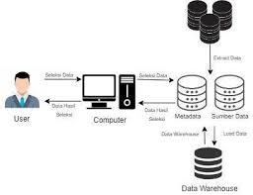

4.2 Flowchart:

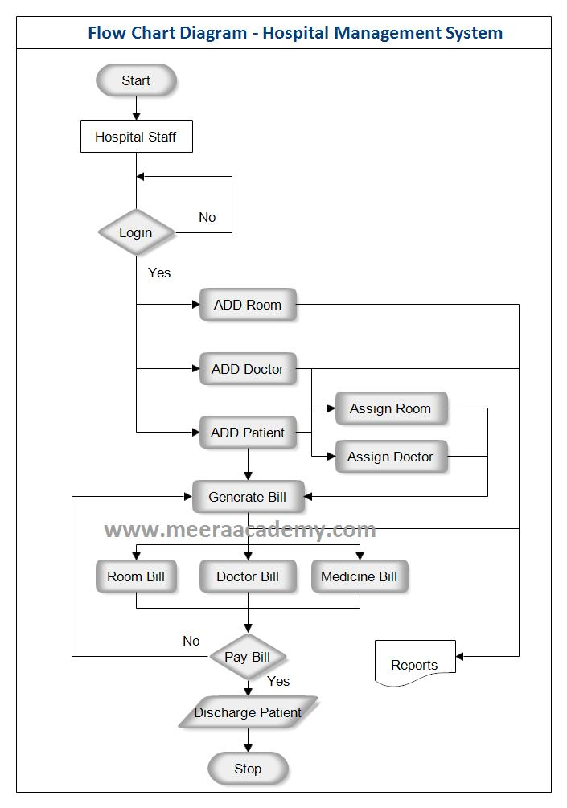

4.3 Basic Functions/Module details:

* Management of Patient Reports.
* Management of Patient bookings.
* Management of hospital features.
* Management of Doctor’s details.
* Management of Patient’s details.

4.4 Project Code:

<https://github.com/Prateekmathur0921/Hotel-Management-System>

4.6: Project Screenshots:

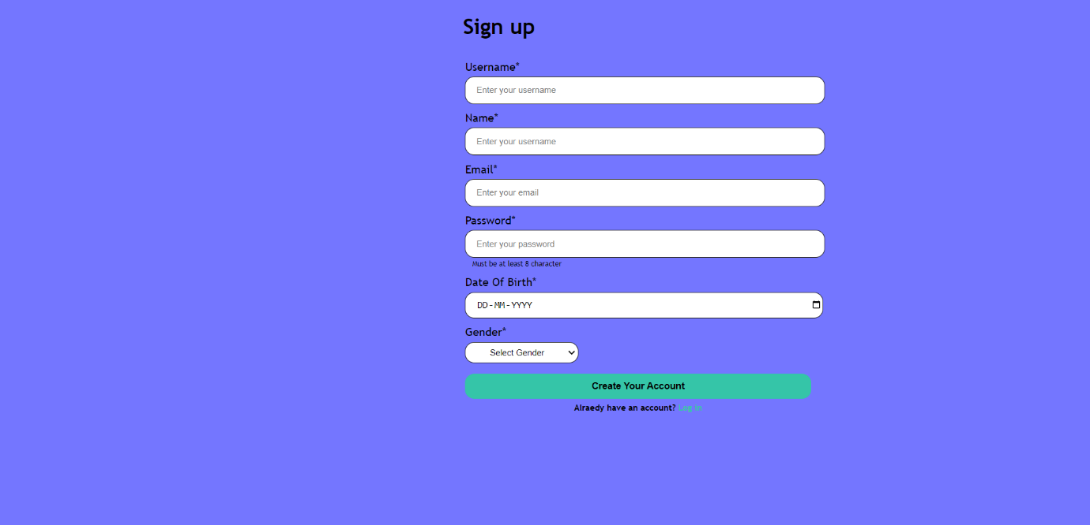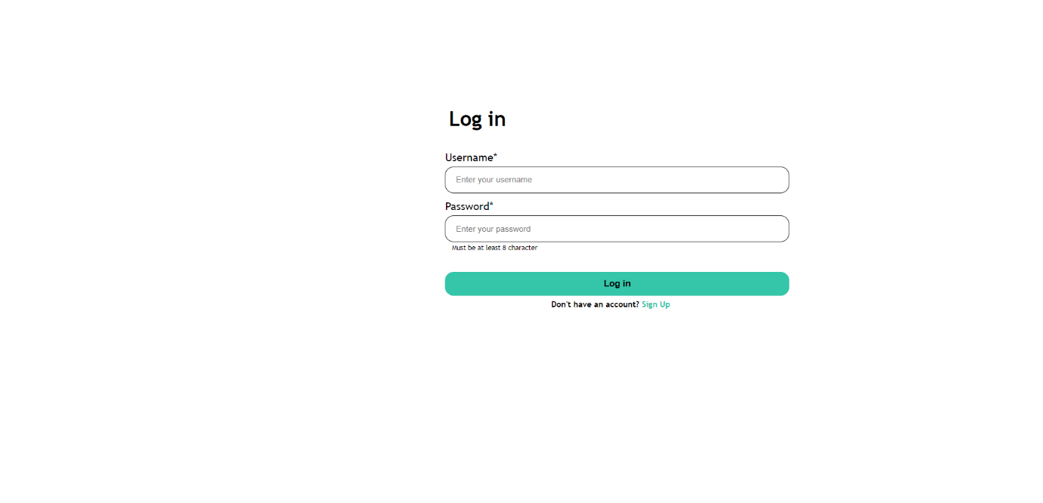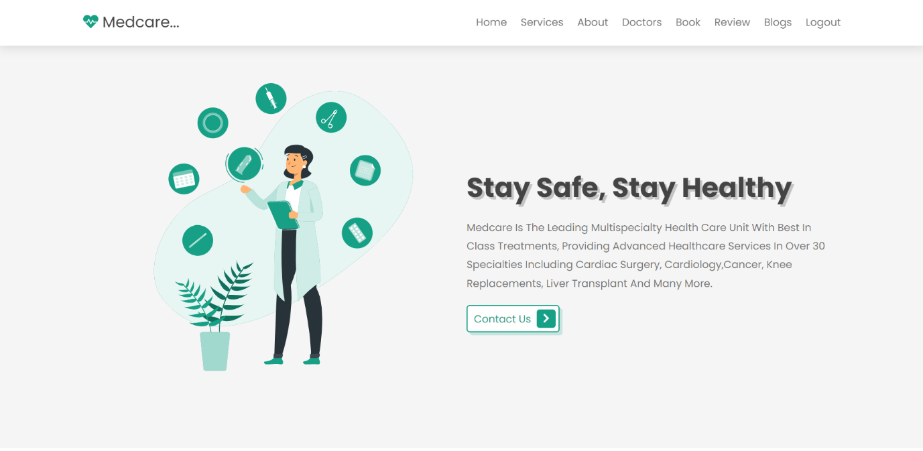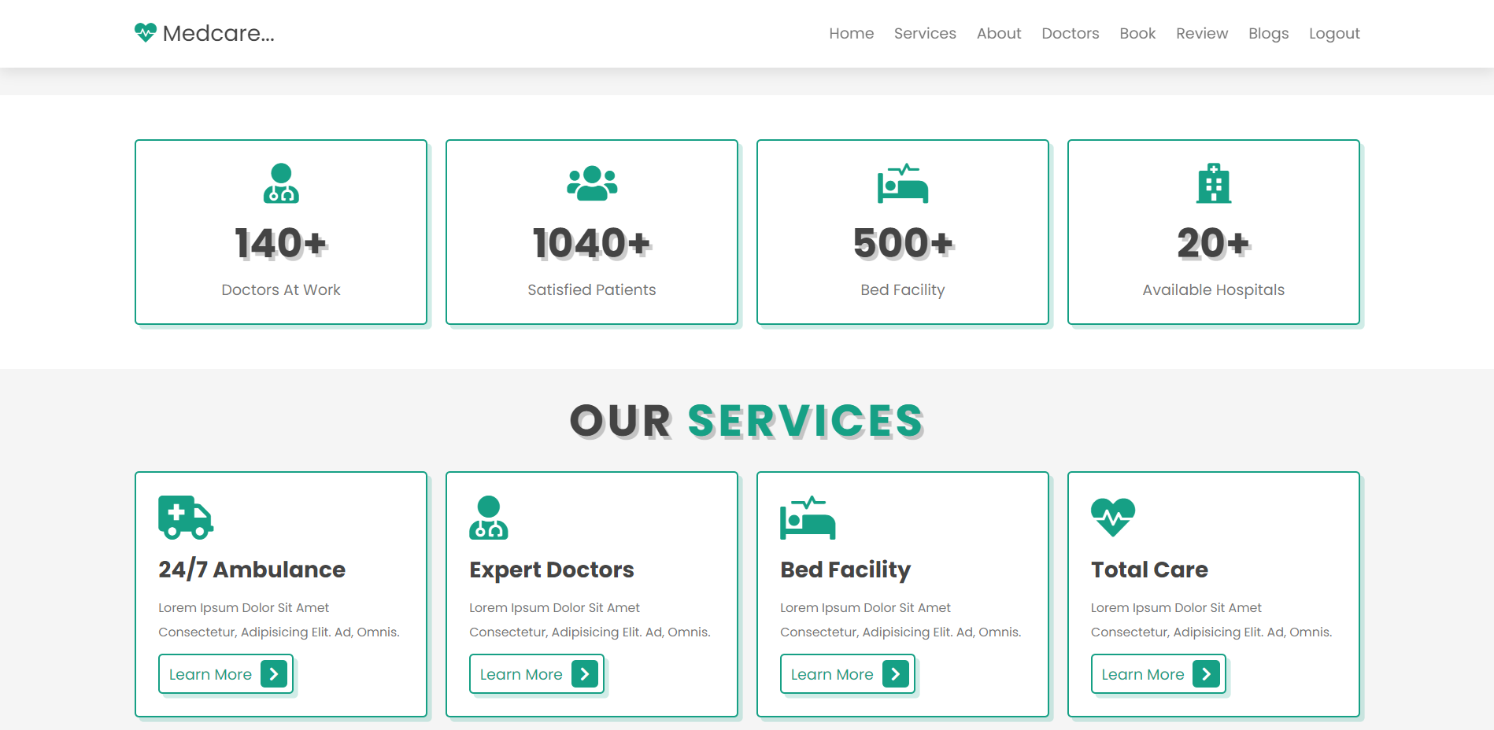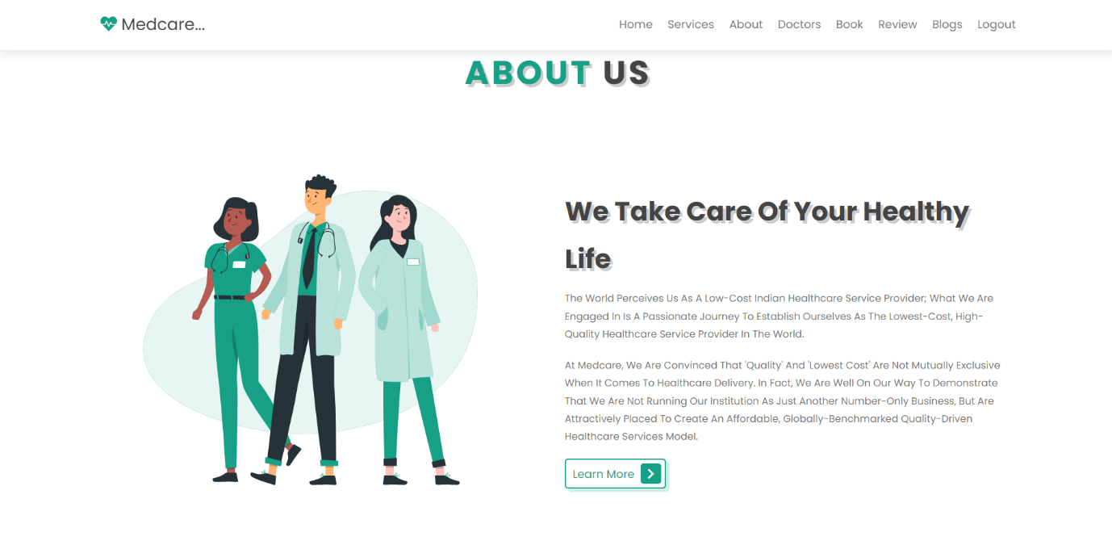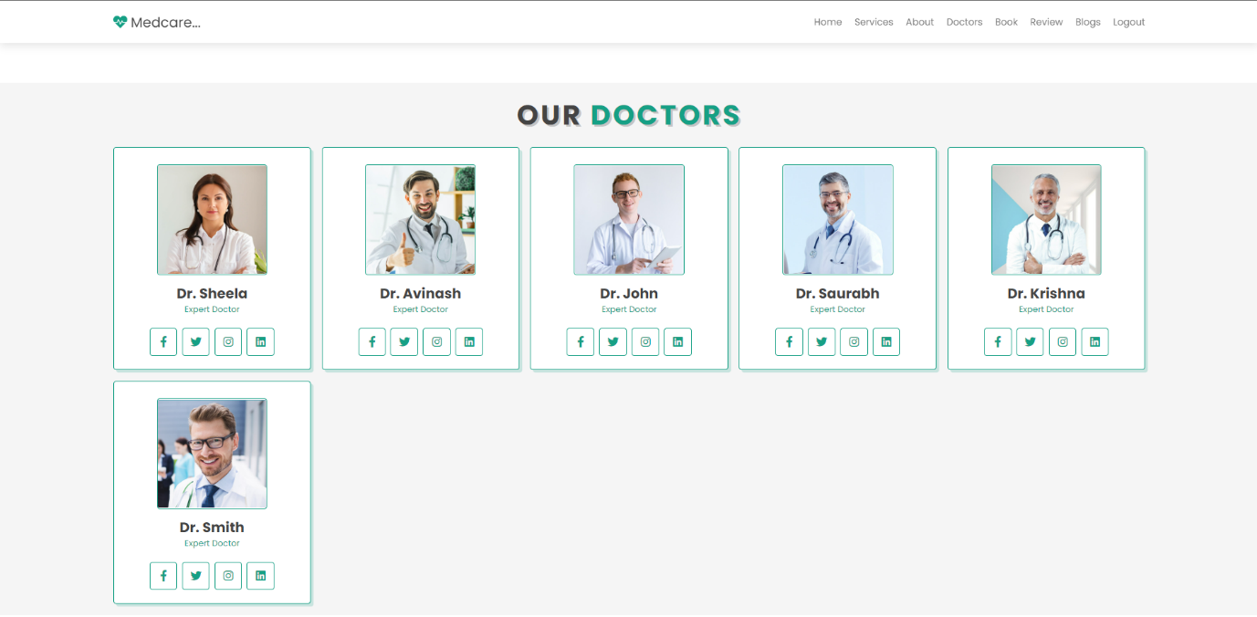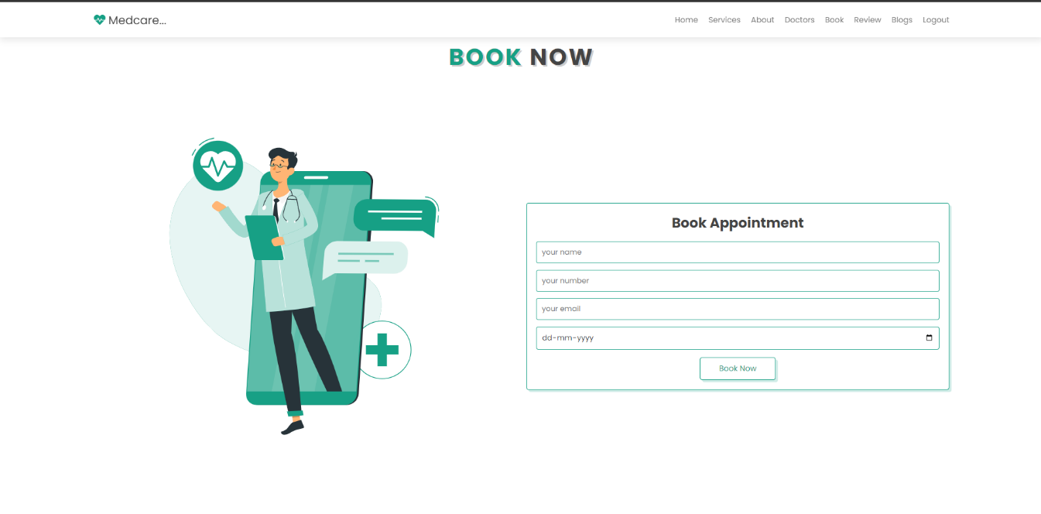

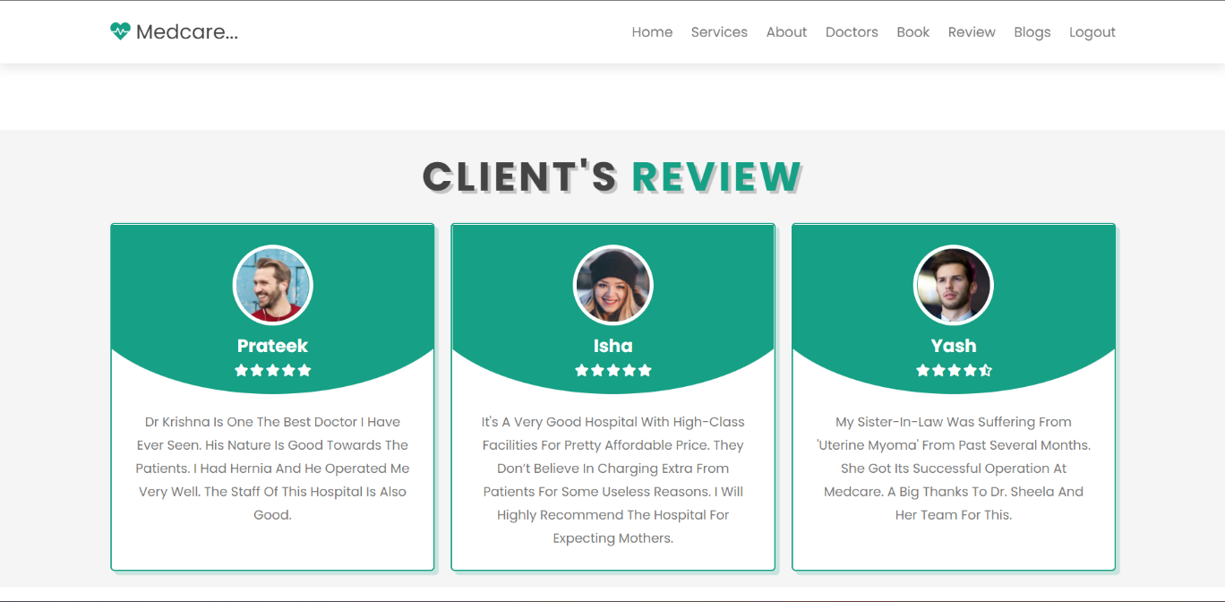

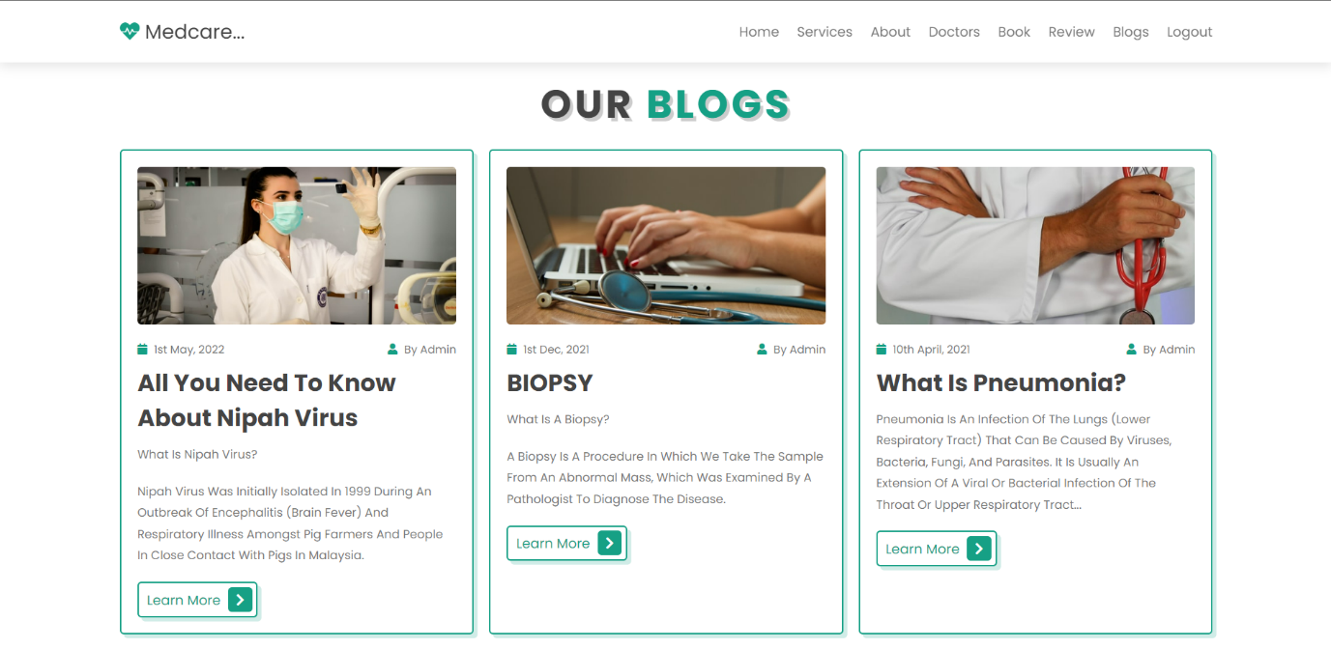

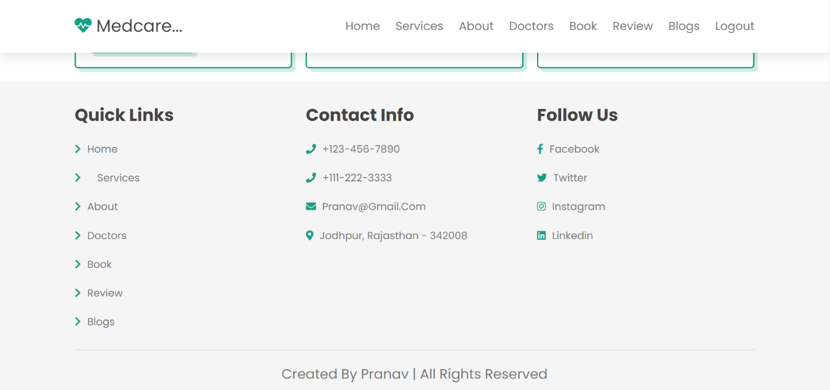

**5. APPLICATIONS**

**________________________________**

### **1**. **A friendly and convenient UI/UX design:**

### **A friendly and convenient UI/UX design**is one of the top priorities for such applications, considering the large number of potential users. Both medical staff and patients need an informative and convenient system, which is easy to use effectively regardless of age and computer skills.

### **2. HMS WITH EXCELLENT BILLING FEATURES:**

## The billing procedure in a hospital can get complicated, especially if there are insurance issues. However, it is good to know that through an excellent HMS, you can simplify your billing process and have it automated to reduce time wasting and confusion. In most cases, getting billed from a hospital can include a lot of paperwork, mainly if the patient used various services like pharmacy and radiology services, for example. Invoicing also becomes a problem if each department is to be cleared with independently.

## **3.** **ELECTRONIC MEDICAL RECORD KEEPING:**

## One of the main advantages of technology is that it reduces the workload. In a health facility or example, one of the most significant challenges is typically accurate record keeping. Some patients will even take years before they can fall ill and return for health attention. Accessing the previous records of such a patient can be tricky if the file was not backed up digitally.

The best electronic medical record keeping should offer a cloud back-up to allow the doctors and even nurses to access information about a patient fast easily. This will make it quick and easy to attend to your patients with fewer chances of mixing up information. Electronic data keeping also makes it easy to track and update treatment processes for all your patients.

## **4**. **URGENT CARE APP:**

Almost everybody today uses a smartphone, a computer or at least has access to one. This makes it easy for a health care centre to reach out and serve its patients, even in their homes. In many occasions, not everyone visiting the hospital requires health services. Some are there to make inquiries while others go to seek medical information.

### **5. Prevent double bookings and manual errors:**

Hospitality management software systems are programmed to **avoid double bookings and**[**overbookings**](https://www.mews.com/en/blog/hotel-overbooking-strategy). Thanks to task automation, they also help prevent errors when front desk staff are inputting important customer data like name, personal details, and card numbers.

This means a better Patient’s experience (no awkward follow up conversations asking for their correct details), more time for staff to focus on their important work, and more reliable business data and reporting.

### **6. Patient self-service:**

### Patients have their own system accounts where the list of various actions can be performed. They are able to make online requests or reservation, receive the test results, receive the consultation of the medical specialists and many more.

### **7. PHARMACY AND STOCK MANAGEMENT:**

Typically, any health facility will have medicine and other health-related items in their pharmacy inventory. Since patients buy these products, it is crucial to keep a close watch your stock to avoid unexpected losses. Keeping track of your inventory will not only protect your investment but will also make it easy for you to track the patients’ medication records.

It is safe to say that any services provided in a health facility fall under the stock. That is why there are some HMS that have extensive administrative capabilities and can be used to manage things like radiology and more. A sound stock management system will allow you to improve your margins and understand better the kind of patients you are dealing with.

**6. Conclusion**

**____________________________**

Hospital management system is all about the modernizing a hospital through use of technology. Computers helps in it and take over the manual system for quick and easy functioning. This hospital management system is a quite the reliable and is proven on many stages. All the basic requirements of the hospital are provided in the hospital in order to manage it perfectly and large amount of data can also be stored. It gives many facilities like searching for the detail of patient, billing facilities as well as the creation of test reports. So, it’s an important system for modern days

7. REFERENCE

_______________________

• <https://www.w3schools.com/html>

• <https://www.w3.org/style/css>

• <https://wikepedia.or/wiki/MySQL>

• <https://wikipedia.org/wiki/javascript>

• <https://httpd.apache.org>

• <https://w3schools.com/php>

• Learning PHP, MySQL & JavaScript: With jQuery, CSS & HTML